# Project Design Phase-I

**Solution Architecture**

|  |  |
| --- | --- |
| Date | 05 November 2022 |
| Team ID | PNT2022TMID11798 |
| Project Name | Real time water quality monitoring and control  system |
| Maximum Marks | 4 Marks |

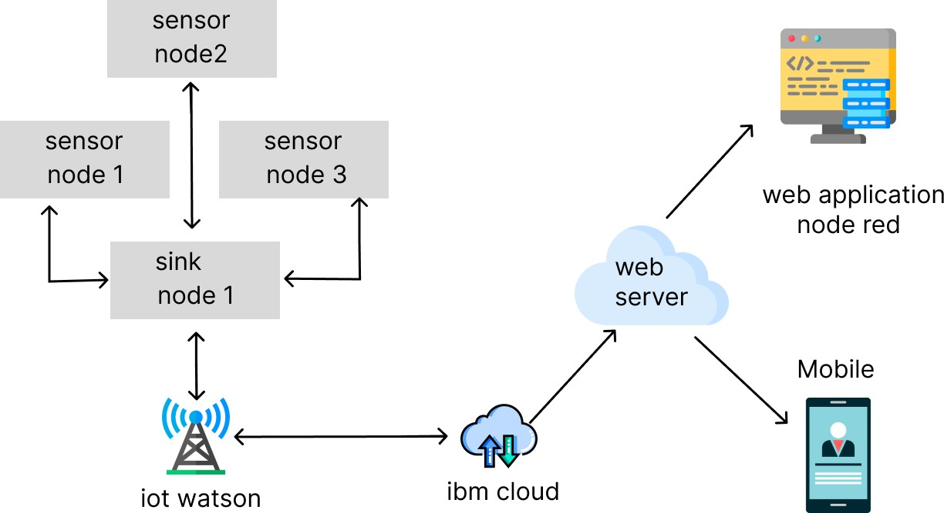

# Sensors:

* Getting information about the quality of the water.
* Various sensors are used to get the information.
* Then gathered information is sent to the IOT platform.

# Create and Configure IBM cloud platform services:

* Create IBM Watson IOT platform
* Create a device & configure the IBM IOT Platform
* Create Node-Red service
* Create a database in IBM Cloudant DB to save the sensor’s readings.

# Develop a web application using Node-RED service:

* Develop a web application using Node-RED.
* Develop a python script to publish the readings of the sensors and threshold readings of the quality of water to remind details to the IBM IOT Platform.

# Develop an application:

* Develop an application in which the user can view the readings of the sensors
* Develop an application which can alert the user by sending alert messages.